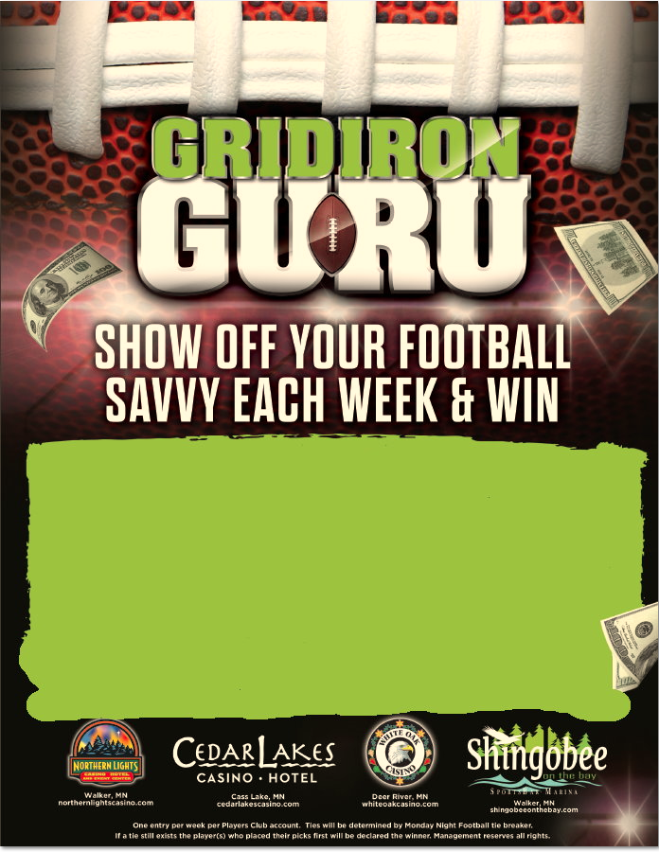

* Swipes can only be done at the promotional kiosks.
* One entry per week per Players Club account.
* Players must pick what teams they think will win the designated games.
* Top 10 players each week will be awarded the designated prize.
* Ties will be determined by the Monday Night Football tie breaker.
* In the case a tie is still at hand the player(s) who placed their picks first will be declared the winner
* Weekly winners will be posted at individual Players Club and on Shingobee digital signage every Tuesday by 12pm.
* Weekly winners will have until 11:59am the following Tuesday to claim their prize by swiping their card at a promotional kiosk
* Players can only qualify once for the playoffs.